Pollution prediction using LSTM

Isam Al Jawarneh College of Computing and Informatics

University of Sharjah  
Sharjah, United Arab Emirates  
[ijawarneh@sharjah.ac.ae](mailto:ijawarneh@sharjah.ac.ae)

Madyan Omar Ibrahim Bagosher  
*College of Computing and Informatics*

*University of Sharjah*Sharjah, United Arab Emirates  
U23200049@sharjah.ac.ae

Fatemeh Mohammadi Aghjehmashhad  
 *College of Computing and Informatics*

*University of Sharjah*Sharjah, United Arab Emirates  
U23200047@sharjah.ac.ae

*Abstract*— With the advancement of industrialization, air pollution has emerged as a significant concern.

Keywords— Correlation coefficient, correlation matrix, forecasting, Geohash, LSTM, pollution, RMSE.

# Introduction

This ….

# BBasic Information about our data

## Basic Information about fine-grained low cost air quality (AQ) data

Various components can be considered when determining air quality. In our data, we focus on “pollution” and the geographic locations in New York City. The maximum pollution value and the minimum value are 12.74 and 1.57, respectively. The following picture is a histogram of pollution values which help us to understand the overall distribution of pollution levels.

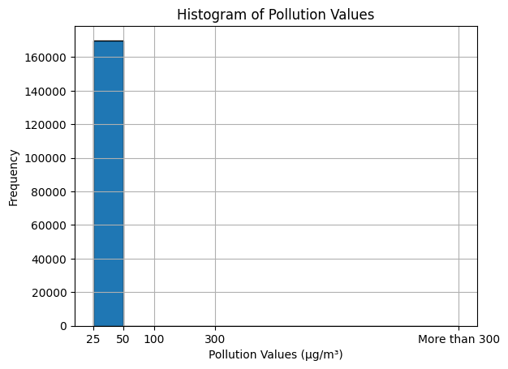

The histogram shows a left-skewed (or negatively skewed) distribution, indicating that the majority of the pollution values are low, with fewer instances of very high pollution levels. The highest bar is in the first interval, suggesting that most pollution measurements are at the lower end of the scale, possibly within clean to moderately polluted air quality ranges. The skewness of the data suggests that median value would be more representative of typical pollution levels than mean value.

Also, we can see the pollution distribution across days of the week in the following picture:

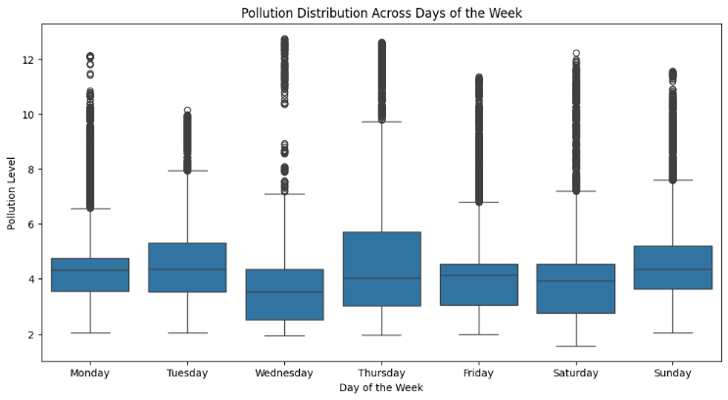

Additionally, we can see the pollution distribution across months in the following picture:

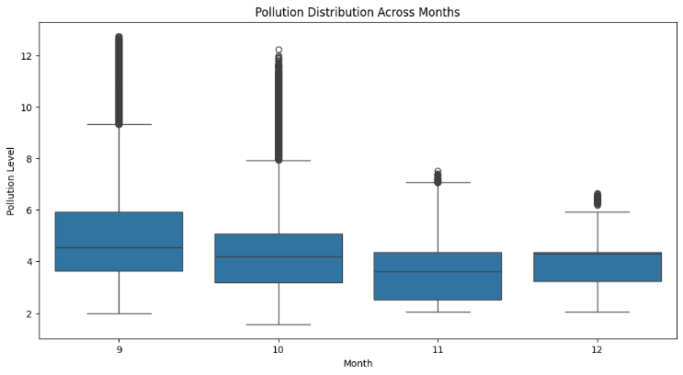

Also, the following map can help us to visualize the spatial distribution of pollution levels:

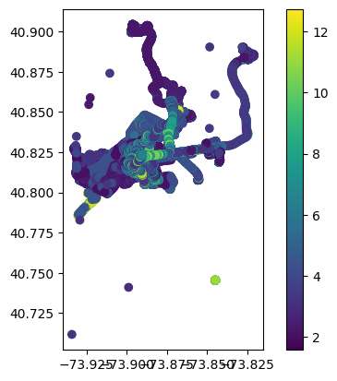

We can see areas with high and low pollution concentration.

The data was covered from 2021-09-10 at 12:29:09 to 2021-12-15 at 14:35:55 which makes 96 days and 02:06:46.

For investigating temporal trend of pollution, we plot the fluctuation of pollution levels over time in the following figure:

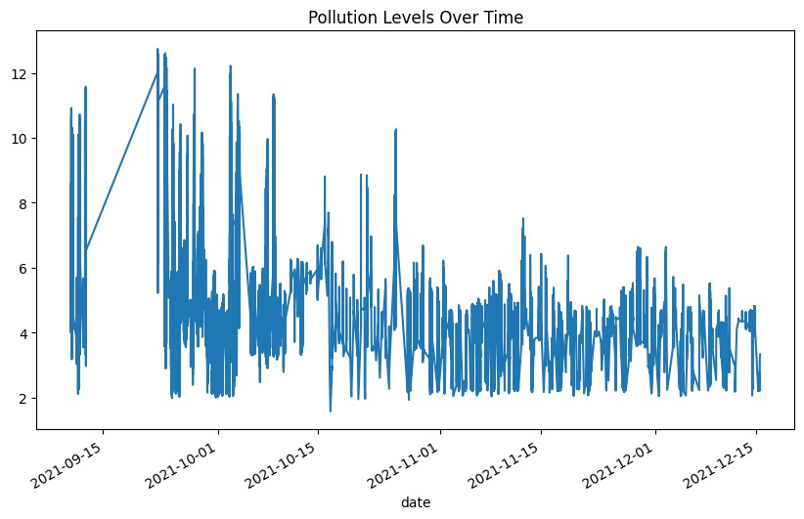

The plot shows a significant variation in pollution levels over time. There are visible peaks and troughs indicating that on some days, pollution levels were much higher than on others. There appears to be a downward trend in pollution levels as time progresses. Initially, there are more instances of higher peaks, which seem to become less frequent towards the end of the time series. The sharp spikes, especially noticeable at the beginning of the time series, suggest transient events that caused pollution levels to shoot up. These could be due to specific incidents, like industrial releases, traffic congestion, or other episodic events. The continuity of the data indicates consistent monitoring without apparent gaps in data collection, which is good for analysis.

Also, we provide the graph for other variables in the data such as: Latitude, Longitude, temperature, humidity and pollution as follow:

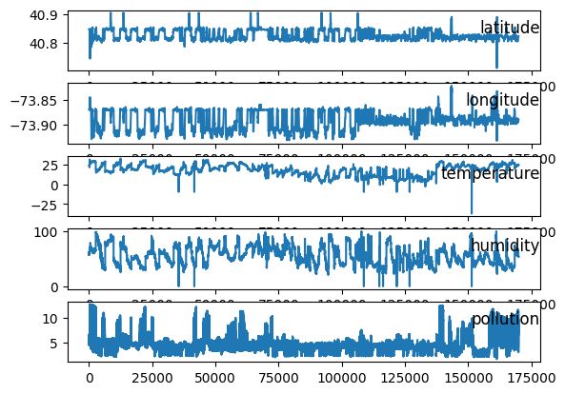

# VVisualization

## Pollution Distribution in New York City

First, by creating the scatter plot on top of a map of New York City (nyc_map), we managed to visualize pollution data. In fact, the following map provides spatial context for understanding the *distribution of pollution* within New York City, where each point on the map represents a pollution data point, and the size of the point reflects the pollution level.

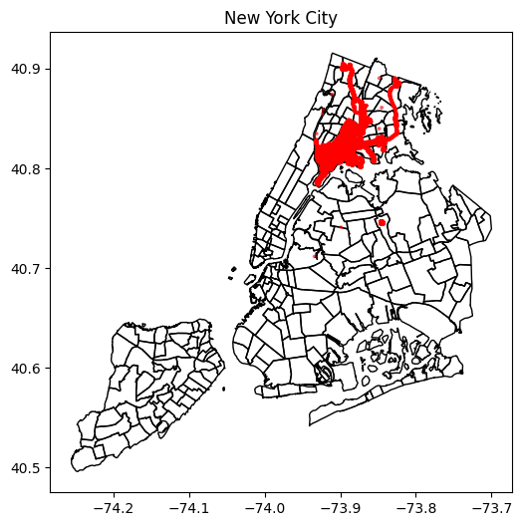

From this map, we can see where pollution is concentrated and how it spreads across different areas within the city.

Additionally, the following scatter plots help us to visualize pollution levels in each area.

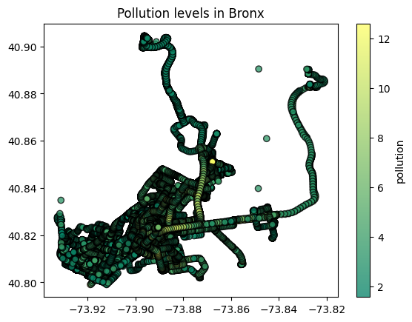

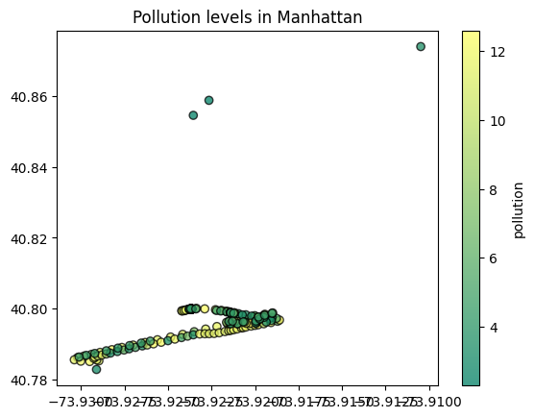

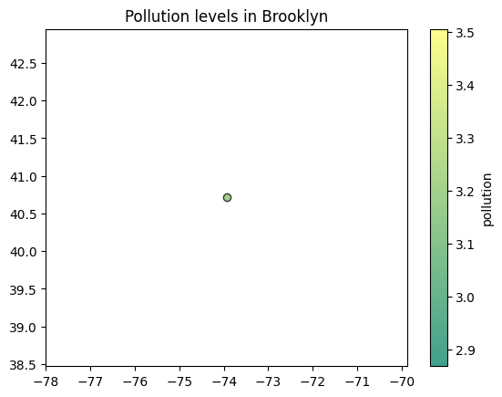

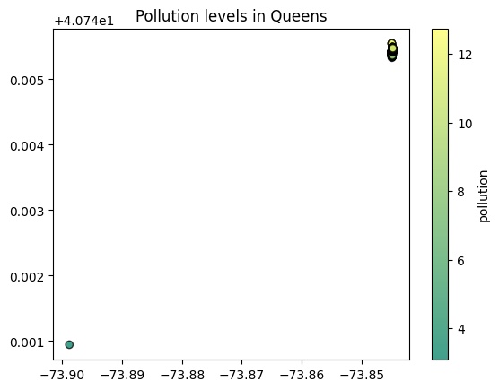

## Correlation Matrix

We recall that a correlation matrix is a table that shows the correlation coefficients between variables in a dataset. Each cell in the table represents the correlation coefficient between two variables. The correlation coefficient measures the strength and direction of the linear relationship between two variables. It ranges from -1 to 1, where:

* 1 indicates a perfect positive linear relationship
* -1 indicates a perfect negative linear relationship
* 0 indicates no linear relationship

We calculated the correlation matrix for our data and it looks like the “Temperature” is the variable that has the highest correlation with the response variable “Pollution”, at the par with 0.49. This suggests that higher temperatures might be associated with higher levels of pollution. 'Temperature' and 'humidity' show a moderate negative correlation of -0.22, which could indicate that higher temperatures often correspond to lower humidity levels. Several pairs of variables, like 'humidity' and 'pollution rank' (-0.05), show little to no correlation, indicating no linear relationship between these variables.

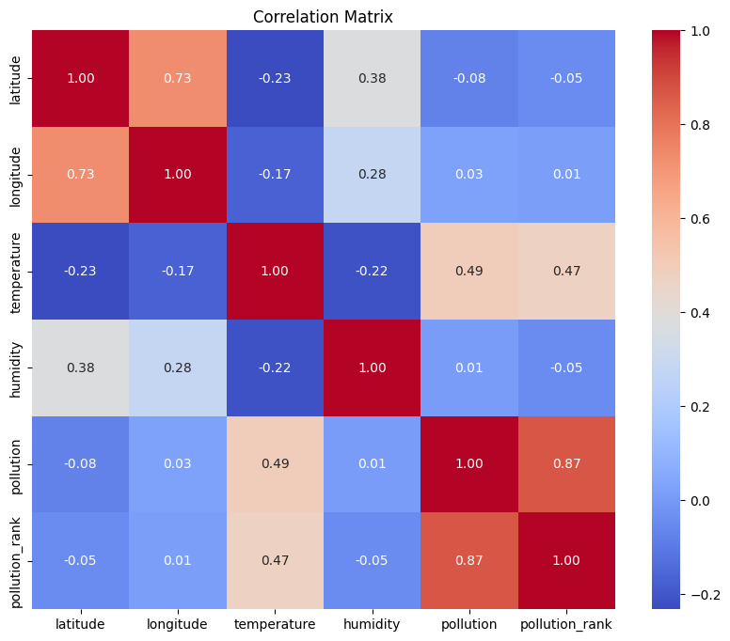

# SSEVERAL CORRELATION COEFFICIENTS

In this section, we want to investigate any association between pollution (also pollution rank) with geohash variable using several methods:

## Reverse Kendall's correlation coefficient

We calculated the average rank of pollution values per geohash category as well as the size of each geohash category (i.e., the number of observations in each category).Since both are ordinal data, it is suitable to use Reverse Kendall's correlation coefficient in order to find the association between the average rank of pollution values (ordinal data) and the size of each geohash category (ordinal data). Also, we repeated this strategy by using the neighborhood variable and borough variable instead of geohash variable, and we got the following results:

* Using “geohash” variable:
* Reverse Kendall's correlation coefficient: 0.18607703406282353
* Using “neighborhood” variable:
* Reverse Kendall's correlation coefficient: 0.3031491751402424
* Using “borough” variable:
* Reverse Kendall's correlation coefficient: 0.19999999999999998

One can see that the association between the average rank of pollution values per neighborhood category and the size of each neighborhood is positive and is higher than the other. Larger neighborhoods, which likely correlate with higher population density or more intense urban activities, tend to have higher pollution levels. This suggests that as the activity and population in a neighborhood increase, so does the pollution, potentially due to factors like traffic, industrial emissions, and commercial activities. This would indicate that larger neighborhood areas tend to have higher pollution levels on average.

Also, it is notable that the size of geohash areas and the average pollution rank shows the weakest association, suggesting that geohashes do not align as closely with factors that influence pollution levels. Since geohashes are arbitrary geographic divisions, they might not correspond well with natural or urban boundaries that impact pollution, such as roads, industrial zones, or natural barriers.

Also, we repeated the above algorithm with different precision=[3, 4, 5]. We got the following results:

* Reverse Kendall's correlation coefficient for geohash: 1.0
* Reverse Kendall's correlation coefficient for neighborhood: -0.10734744162189888
* Reverse Kendall's correlation coefficient for borough: -0.39999999999999997

We got the same result for each precision in [3,4,5], and this can suggest that additional precision beyond a certain point doesn't significantly alter the ordering of the geohash (respectively, neighborhood and borough) categories concerning pollution ranks. As we can see the association between the average rank of pollution values per geohash category and the size of each geohash is positive and perfect. This implies that within each truncated geohash (precision reduced to 3, 4, 5), there is a perfect alignment between the size of the geohash category and the average pollution rank. This makes sense, since the geohash precision is reduced, each category might encompass a smaller number of data points or a more uniform area. This creates a scenario where the more observations within a geohash, the higher the rank of pollution observed, simply due to uniform distribution of few varied data points.

On the other hand, the correlation coefficient of -0.107 between the average rank of pollution values per neighborhood category and the size of each neighborhood indicates a very slight negative correlation, suggesting that as the number of observations in neighborhoods increases, the average pollution rank slightly decreases. This might imply that larger neighborhoods (or those with more data points) do not necessarily have higher pollution levels, possibly due to effective pollution control, larger green spaces, or less dense industrial activity.

## Spearman's Rank Correlation Coefficient

This measures the strength and direction of association between the ranks of 'geohash' (respectively, neighborhood and borough) and 'pollution'. It is suitable when the relationship is monotonic but not necessarily linear. We remind that for calculating the Spearman's Rank Correlation Coefficient, one can use the following formula:

$ρ=1-\frac{6\sum{d^{2}}}{n(n^{2}-1)}$, (1)

where

ρ (rho) is Spearman's rank correlation coefficient.

Σd² is the sum of the squared rank differences and n is the number of observations. This formula assesses how well the relationship between two variables can be described using a monotonic function. If *ρ*=1, there is a perfect positive monotonic relationship, and if *ρ*=−1, there is a perfect negative monotonic relationship. A *ρ* close to 0 suggests no monotonic relationship.

First, we calculated the Spearman's Rank Correlation Coefficient between 'geohash' (respectively, neighborhood and borough) and 'pollution' without applying precision, and we got the following:

* Spearman's Rank Correlation Coefficients:
* Geohash vs. Pollution: -0.06654169631677545
* Neighborhood vs. Pollution: 0.011637772263997271
* Borough vs. Pollution: 0.08611017903128607
* P-values:
* Geohash vs. Pollution: 4.454497640901313e-166
* Neighborhood vs. Pollution: 1.5984415142310416e-06
* Borough vs. Pollution: 4.068933168365492e-277

From the result, one can see that overall there is generally a weak association between the ranks of geographic categorizations (geohash, neighborhood, and borough) and pollution. For example, the correlation coefficient of −0.066 indicates a very weak negative monotonic relationship between geohash and pollution. This suggests that increases in geohash ranks are weakly associated with decreases in pollution ranks, but the relationship is not strong or may not be significant. The extremely small p-value (approx. 4.454×10−16) suggests that the result is statistically significant, even though the correlation itself is weak.

Second, we calculated the Spearman's Rank Correlation Coefficient between the ranks of 'geohash' and 'pollution' with different precision=[3, 4, 5]. The results are as follow:

* Spearman's Rank Correlation Coefficients for Geohash:
* Precision 3: -0.06654169631677545
* P-value: 4.454497640901313e-166
* Precision 4: -0.03478746127459427
* P-value: 1.1042075713576446e-46
* Precision 5: -0.005006042655342761
* P-value: 0.03901315711545015

From the results,, we can conclude that as the precision of the geohash increases from 3 to 5, the magnitude of the correlation coefficient decreases, moving closer to zero. This suggests that as geohash precision increases—thereby defining smaller and more localized geographic areas—the association between geohash and pollution levels becomes weaker.

## ANOVA (Analysis of Variance)

ANOVA, or Analysis of Variance, is a statistical method used to analyze the differences among means of three or more groups. It assesses whether the means of different groups are statistically significantly different from each other. ANOVA tests the null hypothesis that all group means are equal against the alternative hypothesis that at least one group mean is different.

We need the F-statistic and p-value for the ANOVA test. We recall that the F-statistic measures the ratio of the variance between groups to the variance within groups. And the p-value indicates the probability of obtaining the observed results (or more extreme results) if the null hypothesis is true. The decision rule is that if the p-value is less than a chosen significance level (e.g., 0.05), we can reject the null hypothesis and conclude that there are statistically significant differences in pollution levels across different geohash (respectively, neighborhood and borough) categories. Otherwise, we fail to reject the null hypothesis, suggesting no significant differences in pollution levels between the groups.

First, we show the ANOVA test results for 'geohash' (respectively, neighborhood and borough) and 'pollution' without applying precision:

* ANOVA Test Results:
* Neighborhood - F-statistic: 194.2967984990712, P-value: 0.0
* Borough - F-statistic: 1571.4452929273557, P-value: 0.0
* Geohash - F-statistic: 3520.2944091142294, P-value: 0.0

These results provide a clear indication that pollution levels vary significantly across different geographic scales (geohash, borough, and neighborhood).

More precisely, the F-statistic for geohash is the highest (3520.2944091142294), indicating that the differences in mean pollution levels among different geohashes are the most pronounced among the three categorizations. This suggests a strong spatial variability in pollution distribution at the geohash level.

On the other hand, the F-statistic for borough (1571.4452929273557) is substantial but lower than that for geohash, indicating significant but less pronounced differences among boroughs compared to geohashes.

It is noticeable that neighborhoods, while still showing significant differences with an F-statistic of 194.2967984990712, exhibit the least variability among the three. This suggests that pollution levels within neighborhoods are more homogeneous compared to the larger categorizations of boroughs and geohashes.

These facts are supported by the p-value as well. A P-value of 0.0 is highly statistically significant. This result provides strong evidence to reject the Null hypothesis, indicating that there are significant differences in pollution levels between the different geographic categorizations.

Second, we show the ANOVA test results for 'geohash' and 'pollution' with applying precision=[3, 4, 5]:

* ANOVA Test Results:
* For geohash:
* Precision Level precision_3: F-statistic = 3520.2944091142294, P-value = 0.0
* Precision Level precision_4: F-statistic = 1762.629585813516, P-value = 0.0
* Precision Level precision_5: F-statistic = 412.3721028769785, P-value = 0.0

One can see that as the precision level of geohash increases, the F-statistic decreases. This indicates that as the geohash codes become more fine-grained (moving from precision 3 to 5), the differences in mean pollution levels between geohash categories become less pronounced. For example at Precision 5, the F-statistic is significantly lower, indicating that the more localized the geohash, the less variance there is among the categories in terms of pollution levels.

The P-value of 0.0 across all precision levels indicates that the differences observed in mean pollution levels are statistically significant allowing us to confidently reject the null hypothesis which states there are no differences.

## Kruskal-Wallis test

The Kruskal-Wallis test is a non-parametric method used to determine if there are statistically significant differences between the medians of two or more independent groups. It is especially useful when the assumptions required for ANOVA test are not met, such as when the data are not normally distributed or when the groups have unequal variances.

First, we show the Kruskal-Wallis test results for 'geohash' (respectively, neighborhood and borough) and 'pollution' without applying precision:

* Kruskal-Wallis Test Results:
* Neighborhood: Statistic = 3194.7088275131123, P-value = 0.0
* Borough: Statistic = 1281.6427998977276, P-value = 3.178456778603967e-276
* Geohash: Statistic = 752.7255492814534, P-value = 1.025109961523071e-165

In all cases, the extremely small P-values indicate that the results are statistically significant, allowing us to reject the null hypothesis that the medians of pollution levels across different categories are equal. This suggests that there are significant differences in pollution levels between the groups defined by neighborhood, borough, and geohash.

In the case of comparison, neighborhood has the highest statistic among the three categories which indicates the strongest degree of differences among the groups within this categorization. This suggests that neighborhoods vary greatly in terms of pollution levels.

On the other hand, geohash has the lowest statistic. It suggests that while there are still significant differences in pollution levels across different geohashes, these differences are less pronounced than those observed at the neighborhood and borough levels.

Second, we show the Kruskal-Wallis test results for 'geohash' and 'pollution' with applying precision=[3, 4, 5]:

* Kruskal-Wallis Test Results For geohash:
* Precision Level precision_3: Statistic = 752.7255492814534, P-value = 1.025109961523071e-165
* Precision Level precision_4: Statistic = 767.5797478376305, P-value = 2.0997884702223404e-167
* Precision Level precision_5: Statistic = 1549.7445498734908, P-value = 0.0

It is clear the p-values are very small in all three precision levels. This means we can reject the null hypothesis that states there are no differences in the median pollution levels across different geohash categories at each respective precision level.

Interestingly, the Kruskal-Wallis statistic significantly increases from precision level 4 to 5. While the statistic initially increases slightly from level 3 to 4, the jump to level 5 is much more noticeable. The increase in the Kruskal-Wallis statistic with finer geohash precision suggests that as we zoom in further (higher precision), the differences in pollution levels across smaller geographical areas become more noticeable.

## Kendall's Tau Correlation Coefficient

This measures the strength and direction of association between the ranks of 'geohash' and 'pollution'. It is suitable for ordinal data or when the relationship is not necessarily linear.

Kendall's Tau is a rank-based correlation coefficient that measures the ordinal association between two variables. We calculated the Kendall's Tau correlation coefficient and the associated p-value. The correlation coefficient ranges from -1 to 1. The p-value indicates the significance of the correlation coefficient. If the p-value is less than a chosen significance level (e.g., 0.05), we can reject the null hypothesis and conclude that there is a statistically significant association between 'geohash' and 'pollution'. Otherwise, we fail to reject the null hypothesis, suggesting no significant association. We got the following results by applying precision=[3, 4, 5]:

* Kendall's Tau Correlation Coefficient Results for neighborhood:
* For neighborhood: Correlation = 0.009259718338660744, P-value = 1.3397951600462843e-07
* Kendall's Tau Correlation Coefficient Results for borough:
* For borough: Correlation = 0.07034127731459229, P-value = 4.592161998189867e-276
* Kendall's Tau Correlation Coefficient Results for geohash:
* For geohash Precision Level 3: Correlation = -0.054383698700505266, P-value = 1.0251099615631986e-165
* For geohash Precision Level 4: Correlation = -0.028405622420667093, P-value = 1.2769262199553581e-46
* For geohash Precision Level 5: Correlation = -0.003214327504560284, P-value = 0.08134248790613795

One can see that for two categories neighborhood and borough the correlation is very close to zero but positive, suggesting a very weak direct relationship between neighborhood rank (res. borough rank) and pollution levels.

In the case of geohash, we can say that as precision increases from Level 3 to Level 5, the correlation decreases from a weak negative to almost negligible negative. This trend suggests that the inverse relationship between geohash rank and pollution weakens significantly as the precision increases. At precision level 5, we see that p-value=0.08 and is not less than the significance level= 0.05, and so we do not reject null hypothesis. This means that there is no significant association between 'geohash' and 'pollution' at this level.

# Pollution Prediction using LSTM

## Training the data

The data that we worked on it, is known as *fine-grained low cost air quality (AQ) data*. This data is geo-referenced. We used this data and framed a forecasting problem where, given the pollution (PM, particulate matters) for prior hours, we forecast the pollution at the next 24 hour. The data is a time-series data that we have for several locations, actually street-by-street level locations (granular piecimel precision). We reframed the problem so that it is at each location (represented by a geohash), given the pollution (PM, particulate matters) for prior hours, we forecast the pollution at the next 24 hour.

We split our data into train and test sets. We developed a model specifically skilled at learning from sequences in data — like a sequence of pollution levels throughout a year. After training it on one year of data, we checked its ability to predict pollution for the next four years. This way, we made sure the model wasn't just memorizing; it was truly learning and adapting to make accurate predictions over a longer period.

The following graph shows the training loss and validation loss over the course of 50 epochs from fitting a Long Short-Term Memory (LSTM) neural network.

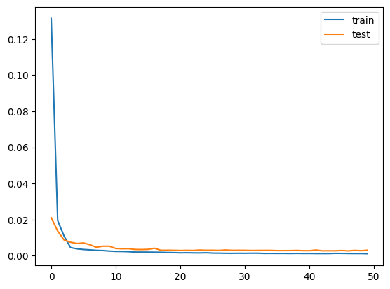

The graph shows that both training and validation loss show a sharp decrease in the initial few epochs, which indicates that the model is learning from the data. After the initial sharp decrease, both lines flatten out, suggesting that the model has reached a point where making further improvements is harder. This means that the model has started to converge on a solution. The final values of the loss functions (training and validation) are very close to each other and close to zero. The close proximity of the training and validation loss suggests that the model is generalizing well and thus should perform similarly on new, unseen data.

## Prediction using LSTM

By tailoring our model to each specific location identified by its geohash, we've created a series of forecasts that predict the levels of particulate matter (PM) pollution for the next 24 hours. Each location's data, shaped by its unique environmental factors and patterns, helps the model to "learn" from the past hours of pollution data and make these hourly predictions. We forecast the pollution at the next 24 hour as follow:

predictions = {

* 'dr5rt': [4.71040125, 5.51816975, 5.73704911, ..., 5.96994891],
* 'dr5ry': [4.71040125, 5.51816975, 5.73704911, ..., 5.96994891],
* 'dr5rz': [4.71040125, 5.51816975, 5.73704911, ..., 5.96994891],
* 'dr72j': [4.71040125, 5.51816975, 5.73704911, ..., 5.96994891],
* 'dr72m': [4.71040125, 5.51816975, 5.73704911, ..., 5.96994891],
* 'dr72n': [4.71040125, 5.51816975, 5.73704911, ..., 5.96994891],
* 'dr72p': [4.71040125, 5.51816975, 5.73704911, ..., 5.96994891],
* 'dr72q': [4.71040125, 5.51816975, 5.73704911, ..., 5.96994891],
* 'dr72r': [4.71040125, 5.51816975, 5.73704911, ..., 5.96994891],
* 'dr72w': [4.71040125, 5.51816975, 5.73704911, ..., 5.96994891],
* 'dr72x': [4.71040125, 5.51816975, 5.73704911, ..., 5.96994891],
* 'dr782': [4.71040125, 5.51816975, 5.73704911, ..., 5.96994891],
* 'dr788': [4.71040125, 5.51816975, 5.73704911, ..., 5.96994891]

}

As an example, the predictions for 'dr5rt' start at a PM level of 4.71040125 and change over the course of 24 hours, ending at 5.96994891. This level of specificity is replicated across all the listed locations, providing an extensive map of predicted pollution levels.

# SSimpleRNN

## SimpleRNN model

We trained the data for the SimpleRNN similar to LSMT. The following graph shows the training loss and validation loss over the course of 50 epochs from fitting a SimpleRNN model.

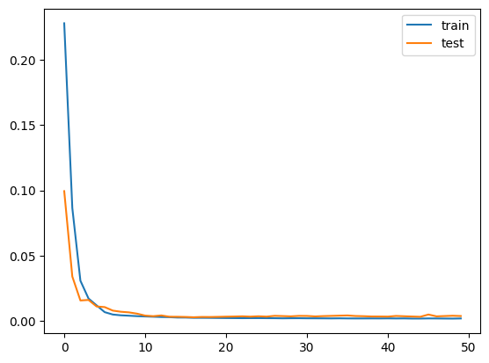

The graph shows that there's a sharp decline in both training and test (validation) loss during the first few epochs. This indicates that the model is rapidly learning from the data at the start of the training process. After that, both losses quickly converge to a low and stable value, which is maintained for the rest of the training process. This suggests that the model is not struggling to fit the data. The training and validation losses are close together and follow a similar trend throughout the training process. The close proximity of the training and validation loss suggests that the model should generalize well when making predictions on new, unseen data.

# RResult Comparison

During the evaluation process, we calculated various metrics such as the mean absolute error (MAE) which is a measure that tells us the average magnitude of the errors in our forecasts. Our Linear Regression model achieves the lowest MAE score followed by the LSTM and RNN models

The next metric we calculated was the mean squared error (MSE) which places a higher weight on larger errors. Once again, our Linear regression model and LSTM model display a low MSE score, followed by our RNN model.

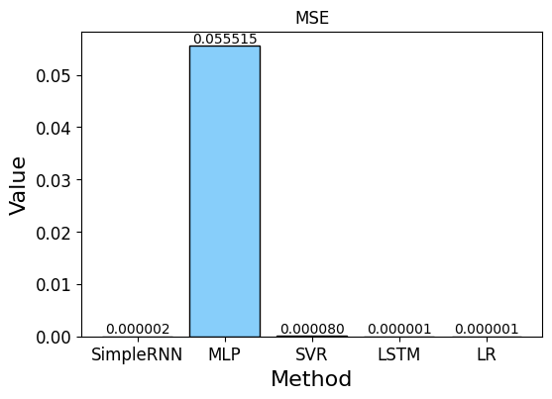

We proceeded to calculate the root mean squared error (RMSE) as well as other metrics such as: Accuracy, Correct prediction count, error rate etc.

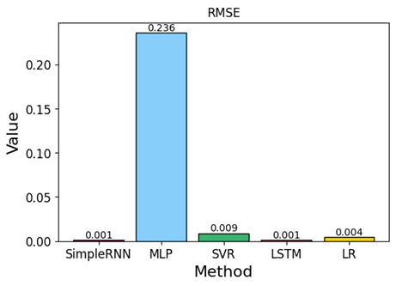

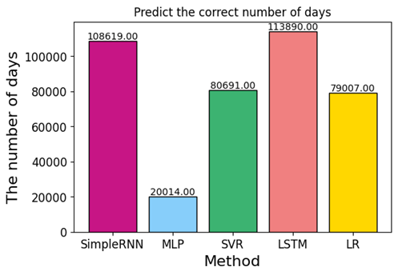

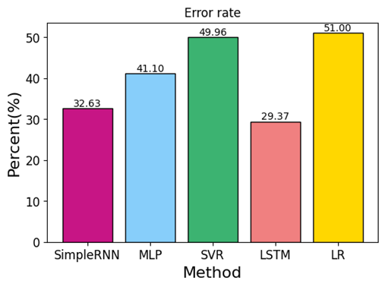

The table below displays the summary of all the metrics rounded up that have been calculated for each of the models.

|  |  |  |  |  |  |  |  |
| --- | --- | --- | --- | --- | --- | --- | --- |
| Model | MAE | MSE | RMSE | Max prediction error | Correct Predictions | Accuracy | Error Rate |
| Long Short-Term Memory (LSTM) | 0.00060 | 0.00000 | 0.001 | 0.088 | 113890 | 70.63 | 29.37 |
| Recurrent Neural Network (RNN) | 0.00069 | 0.00000 | 0.001 | 0.097 | 108619 | 67.37 | 32.63 |
| Multi-Layer perceptron (MLP) | 0.16276 | 0.05552 | 0.236 | 0.793 | 20014 | 58.90 | 41.10 |
| Support Vector Regression (SVR) | 0.00722 | 0.00008 | 0.009 | 0.060 | 80691 | 50.04 | 49.96 |
| Linear Regression (LR) | 0.00011 | 0.00000 | 0.004 | 0.097 | 79007 | 49.00 | 51.00 |

The LSTM model seems to perform the best and achieved the best results.

##### Acknowledgment

We extend our heartfelt thanks to the referee for their thoughtful comments and constructive feedback.

##### References

1. J. Brownlee, (2017, August). Multivariate Time Series Forecasting with LSTMs in Keras. Machine Learning Mastery. Retrieved from <https://machinelearningmastery.com/multivariate-time-series-forecasting-lstms-keras/>
2. J. Brownlee, (2020, August). Feature Selection with Real and Categorical Data. Machine Learning Mastery. Retrieved from <https://machinelearningmastery.com/feature-selection-with-real-and-categorical-data/>